Tai Dam Keyboards

Tai Dam TW layout, Keyman implementation

Updated September 2009
by Jim Brase, SIL International

Contents
Background and overview
Software requirements
Installation and configuration
Activating the keyboard
Modifying the keyboard layout
TaiDamTW keyboard layout charts
License

Background and overview
“Tai Viet” is the name of the script which the Tai people of northwestern Vietnam and surrounding regions use to write their languages. The same basic script, with some variations, is used to write the Tai Dam, Tai Don (called Jinping Dai in China), Tai Daeng, and Thai Song languages.
We anticipate that the Tai Viet script will be included in the next release of The Unicode Standard, version 5.2.
The TaiDamTW keyboard has been designed specifically for typing the Tai Dam language. It is based on the layout of the Tai Dam typewriter created by the Tai Dam community in Des Moines IA in the 1980s.
This implementation of the TaiDamTW keyboard has been built using Tavultesoft Keyman Developer.

Software requirements
- For Windows Vista: requires Tavultesoft Keyman Desktop version 7 or later.
- For Windows XP: requires Tavultesoft Keyman Desktop version 6 or later.
The Keyman Desktop software is available at http://www.tavultesoft.com/.

Installation and configuration
The following instructions are for Keyman 7. If you are using version 6 on Windows XP, see the Keyman documentation.
- If you have not already done so, install Tavultesoft Keyman Desktop version 7.
- Click on the Keyman icon that is in the system tray.
- From the menu, select “Configuration…”.
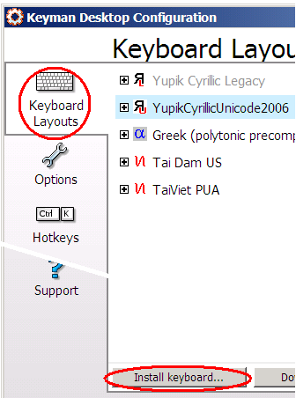
- To install a keyboard:
  - Click on the Keyboard Layouts icon along the left side of the window.
  - Click on the “Install Keyboard” button at the bottom of the window.
  - In the file dialogue, find the TaiDamTW.kmp file and open it.
  - In the next dialogue, click “Install”.
- To be able to select a keyboard by using a hotkey, highlight the name of the keyboard and click on the “Options” button.
- To set other hotkeys (e.g. to set a hotkey to turn Keyman Desktop off), click the “Hotkeys” tab.
- See Keyman Help for information on other configure settings.
- Links to this documentation and the source files can be found by clicking Start / All Programs / Tai Dam TW Keyboard.

Activating the keyboard
To activate the keyboard, either:
- Press the hotkey that you assigned to the Tai Dam TW keyboard. Or
- Click on the Keyman icon that is in the system tray. Select “Tai Dam TW” from the list of keyboards.
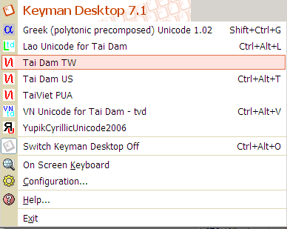

Modifying the keyboard layout
A link to the source files TaiDamTWsource.zip is installed when you install the keyboard. After you install the keyboard, you can access it by clicking Start / All programs / Tai Dam TW Keyboard. Click on the link to the zip file, and extract the contents to a location where you can work with it.
Tavultesoft Keyman Developer is required to edit and recompile the keyboard layout. See http://www.tavultesoft.com/.

TaiDamTW keyboard layout charts

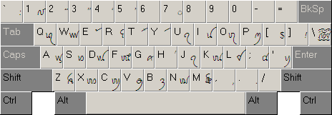
Chart 1: TaiDamTW layout—shifted

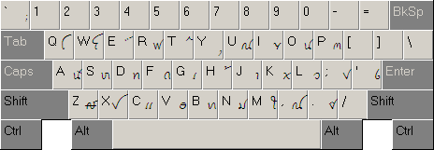
Chart 2: TaiDamTW layout—unshifted

License
The TaiDamTW keyboard (Keyman implementation) is copyright 2009 by SIL International. It is distributed under the X-11 free software license. See http://scripts.sil.org/X11License for the complete text of the X-11 license.
SIL International X11-style License
Permission is hereby granted, free of charge, to any person obtaining a copy of this software and associated documentation files (the "Software"), to deal in the Software without restriction, including without limitation the rights to use, copy, modify, merge, publish, distribute, sublicense, and/or sell copies of the Software, and to permit persons to whom the Software is furnished to do so, subject to the following conditions:
The above copyright notice and this permission notice shall be included in all copies or substantial portions of the Software.
THE SOFTWARE IS PROVIDED "AS IS", WITHOUT WARRANTY OF ANY KIND, EXPRESS OR IMPLIED, INCLUDING BUT NOT LIMITED TO THE WARRANTIES OF MERCHANTABILITY, FITNESS FOR A PARTICULAR PURPOSE AND NONINFRINGEMENT. IN NO EVENT SHALL SIL INTERNATIONAL BE LIABLE FOR ANY CLAIM, DAMAGES OR OTHER LIABILITY, WHETHER IN AN ACTION OF CONTRACT, TORT OR OTHERWISE, ARISING FROM, OUT OF OR IN CONNECTION WITH THE SOFTWARE OR THE USE OR OTHER DEALINGS IN THE SOFTWARE.
Except as contained in this notice, the name of SIL International shall not be used in advertising or otherwise to promote the sale, use or other dealings in this Software without prior written authorization from SIL International.

